Advanced Database Management Project

**Chapter 1: Preparing Your Relational Schema**

**Relational Schema Design**

Using the credits.csv and titles.csv files, we will design a relational schema based on database modeling best practices. Here’s how we can structure the schema:

**Relationships and Constraints**

1. **Primary Keys**:
   * Titles.id (unique title identifier)
   * Genres.genre_id (unique genre identifier)
   * Production_Countries.country_id (unique country identifier)
   * People.person_id (unique person identifier)
   * Roles.role_id (unique role identifier)
2. **Foreign Keys**:
   * Genres.title_id → References Titles.id
   * Production_Countries.title_id → References Titles.id
   * Roles.title_id → References Titles.id
   * Roles.person_id → References People.person_id
3. **Integrity Constraints**:
   * NOT NULL: Applied to essential columns (e.g., title, release_year, role).
   * UNIQUE: Ensures unique values for imdb_id in the Titles table.
   * ON DELETE CASCADE: Ensures dependent rows are removed when a parent row is deleted.

**Populating the Tables**

Here’s the order to populate the tables after you split the data:

1. Populate the Titles table:  
   Import unique title details.
2. Populate the Genres table:  
   Split the genres array into individual rows.
3. Populate the Production_Countries table:  
   Split the production_countries array into individual rows.
4. Populate the People table:  
   Extract unique person_id and name from the Credits table.
5. Populate the Roles table:  
   Map person_id, title_id, role, and character from the Credits table.

Code:-

CREATE TABLE Titles ( id VARCHAR2(50) PRIMARY KEY, title VARCHAR2(255) NOT NULL, type VARCHAR2(50) NOT NULL, description CLOB, release_year NUMBER(4) NOT NULL, age_certification VARCHAR2(10), runtime NUMBER(5), genres CLOB, production_countries CLOB, seasons NUMBER(3), imdb_id VARCHAR2(20), imdb_score NUMBER(3, 1), imdb_votes NUMBER, tmdb_popularity NUMBER, tmdb_score NUMBER(3, 1) );

CREATE TABLE Credits ( person_id NUMBER NOT NULL, id VARCHAR2(50) NOT NULL, name VARCHAR2(255) NOT NULL, character VARCHAR2(255), role VARCHAR2(50) NOT NULL, PRIMARY KEY (person_id, id), FOREIGN KEY (id) REFERENCES Titles(id) );

CREATE TABLE Genres ( genre_id NUMBER GENERATED BY DEFAULT AS IDENTITY PRIMARY KEY, title_id VARCHAR2(50) NOT NULL, genre VARCHAR2(50) NOT NULL, FOREIGN KEY (title_id) REFERENCES Titles(id) ON DELETE CASCADE );

CREATE TABLE Production_Countries (

country_id NUMBER GENERATED BY DEFAULT AS IDENTITY PRIMARY KEY,

title_id VARCHAR2(50) NOT NULL,

country VARCHAR2(50) NOT NULL,

FOREIGN KEY (title_id) REFERENCES Titles(id) ON DELETE CASCADE

);

CREATE TABLE People (

person_id NUMBER PRIMARY KEY,

name VARCHAR2(255) NOT NULL

);

CREATE TABLE Roles (

role_id NUMBER GENERATED BY DEFAULT AS IDENTITY PRIMARY KEY,

title_id VARCHAR2(50) NOT NULL,

person_id NUMBER NOT NULL,

role VARCHAR2(50) NOT NULL,

character VARCHAR2(255),

FOREIGN KEY (title_id) REFERENCES Titles(id) ON DELETE CASCADE,

FOREIGN KEY (person_id) REFERENCES People(person_id) ON DELETE CASCADE

);

Populating the Tables:-

Populate Genres Table:-

INSERT INTO Genres (title_id, genre)

SELECT id, TRIM(REGEXP_SUBSTR(genres, '[^,]+', 1, LEVEL))

FROM Titles

CONNECT BY LEVEL <= REGEXP_COUNT(genres, ',') + 1

AND PRIOR id = id

AND PRIOR DBMS_RANDOM.VALUE IS NOT NULL;

4,106 rows inserted.

Populate Production_Countries Table:-

INSERT INTO Production_Countries (title_id, country)

SELECT id, TRIM(REGEXP_SUBSTR(production_countries, '[^,]+', 1, LEVEL))

FROM Titles

CONNECT BY LEVEL <= REGEXP_COUNT(production_countries, ',') + 1

AND PRIOR id = id

AND PRIOR DBMS_RANDOM.VALUE IS NOT NULL;

1,677 rows inserted.

Populate People Table (From Credits):-

INSERT INTO People (person_id, name)

SELECT DISTINCT person_id, name

FROM Credits;

4,540 rows inserted.

Populate Roles Table (From Credits):-

INSERT INTO Roles (title_id, person_id, role, character)

SELECT id, person_id, role, character

FROM Credits;

5,418 rows inserted

Validate the Data:-

**Check Genres:**

SELECT * FROM Genres WHERE ROWNUM <= 10;

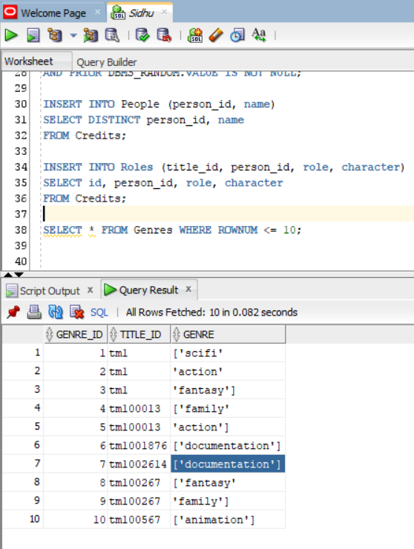

**Check Production Countries**:

SELECT * FROM Production_Countries WHERE ROWNUM <= 10;

**Check People**:

SELECT * FROM People WHERE ROWNUM <= 10;

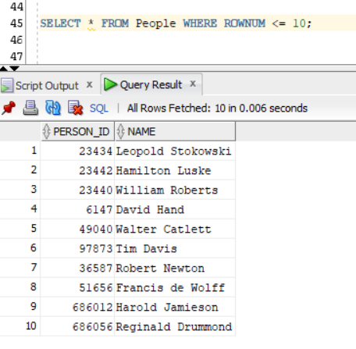

**Check Roles**:

SELECT * FROM Roles WHERE ROWNUM <= 10;

**Chapter 2: Security and User Management:-**

| User | Privileges |
| --- | --- |
| admin_user | Full database access (DBA, CONNECT, RESOURCE) |
| manager_user | Create tables, views, sequences (CONNECT, RESOURCE, etc.) |
| regular_user | Read-only access to Titles and Credits tables |

CREATE USER ##Siddartha_Admin IDENTIFIED BY "1234";

GRANT CONNECT, RESOURCE, DBA TO ##Siddartha_Admin;

CREATE USER C##Manager_Shreeram IDENTIFIED BY "Manager@123";

GRANT CONNECT TO C##Manager_Shreeram;

GRANT SELECT, INSERT, UPDATE, DELETE ON Titles TO C##Manager_Shreeram;

GRANT SELECT, INSERT, UPDATE, DELETE ON Credits TO C##Manager_Shreeram;

CREATE USER C##Abbas_regular IDENTIFIED BY "User@123";

GRANT CONNECT TO C##Abbas_regular;

GRANT SELECT ON Titles TO C##Abbas_regular;

GRANT SELECT ON Credits TO C##Abbas_regular;

**Password Management**

* Set policies for password complexity and expiration.
* Setting password complexity

ALTER PROFILE DEFAULT LIMIT

PASSWORD_LIFE_TIME 30

PASSWORD_REUSE_MAX 5;

**Limiting Sensitive Data Access**

* Use Views or Column Masking to restrict access to sensitive data:

SELECT title, type, release_year

FROM Titles;

GRANT SELECT ON Public_Titles TO C##Abbas_regular;

**Verification**

* Testing the users' permissions by logging in as each user and performing allowed action

CONNECT C##Siddartha_Admin/"1234";

SELECT * FROM Titles;

INSERT INTO Titles (id, title, type, release_year) VALUES ('tm99999', 'Test Movie', 'MOVIE', 2024);

1 row inserted.

GRANT Admin_Role TO C##Siddartha_Admin;

GRANT Manager_Role TO C##Manager_Shreeram;

GRANT Regular_User_Role TO C##Abbas_regular;

REVOKE INSERT, UPDATE, DELETE ON Titles FROM C##Abbas_regular;

**Chapter 3: Queries and Optimization: -**

1. **Designing SQL Queries:**

Query 1: Find the Top 5 Highest-Rated Movies: -

**2: Count the Number of Movies by Genre**

SELECT g.genre, COUNT(*) AS movie_count

FROM Titles t

JOIN Genres g ON t.id = g.title_id

WHERE t.type = 'MOVIE'

GROUP BY g.genre

ORDER BY movie_count DESC;

**3: Retrieve Movies with the Most Appearances of a Specific Actor**

**4: List Directors Who Have Directed More Than 3 Movies**

**5: Calculate the Average IMDb Score for Each Year**

**6: Find the Most Popular Genre in Each Year**

1. **Query Optimization:**
2. Indexing

Create Indexes on Frequently Queried Columns: Indexes speed up search operations:-

CREATE INDEX idx_titles_imdb_score ON Titles(imdb_score);

CREATE INDEX idx_genres_title_id ON Genres(title_id);

CREATE INDEX idx_titles_release_year_genre ON Titles(release_year, type);

Index IDX_TITLES_IMDB_SCORE created.

Index IDX_GENRES_TITLE_ID created.

Index IDX_TITLES_RELEASE_YEAR_GENRE created.

**3. Materialized Views**

CREATE MATERIALIZED VIEW mv_top_movies_new AS

SELECT title, imdb_score, genre

FROM (

SELECT t.title, t.imdb_score, g.genre

FROM Titles t

JOIN Genres g ON t.id = g.title_id

WHERE t.type = 'MOVIE'

ORDER BY t.imdb_score DESC

)

WHERE ROWNUM <= 100;

Materialized view MV_TOP_MOVIES_NEW created.

**4. Query Rewriting & Optimized Using JOIN:**

**Partitioning Tables**

CREATE TABLE Titles_partitioned (

id VARCHAR2(50) NOT NULL,

title VARCHAR2(255) NOT NULL,

release_year NUMBER(4),

imdb_score NUMBER(3, 1),

type VARCHAR2(50),

PRIMARY KEY (id)

)

PARTITION BY RANGE (release_year) (

PARTITION p1 VALUES LESS THAN (2000),

PARTITION p2 VALUES LESS THAN (2010),

PARTITION p3 VALUES LESS THAN (2020),

PARTITION p4 VALUES LESS THAN (MAXVALUE)

);

Table TITLES_PARTITIONED created.

**Analyzing Execution Plans:-**

EXPLAIN PLAN FOR

SELECT t.title, t.imdb_score

FROM Titles t

WHERE t.release_year > 2000;

Explained.

**View the Plan:**

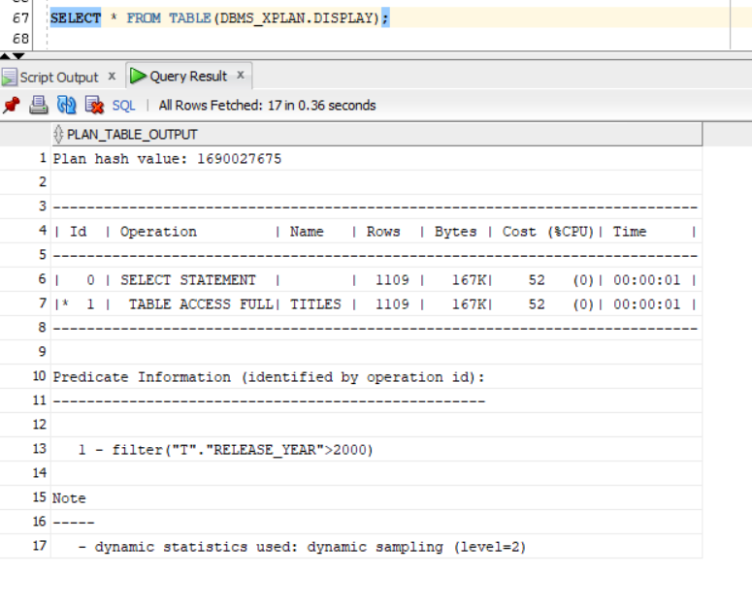

**Avoiding Wildcard Searches: -**

**Inefficient**: Using % at the beginning of a LIKE query disables index use, forcing a full table scan.

**Optimized:**

**5. Creating Indexes**

Indexes improve query performance by reducing the amount of data scanned.

CREATE INDEX idx_release_year ON Titles (release_year);

CREATE INDEX idx_genre ON Genres (genre);

Index IDX_RELEASE_YEAR created.

Index IDX_GENRE created

**6.Materialized Views for Precomputed Data**

Materialized views store the results of expensive queries, reducing runtime for repetitive operations.

CREATE MATERIALIZED VIEW mv_top_movies AS

SELECT title, imdb_score

FROM (

SELECT title, imdb_score

FROM Titles

WHERE type = 'MOVIE'

ORDER BY imdb_score DESC

)

WHERE ROWNUM <= 100;

Materialized view MV_TOP_MOVIES created.

**Chapter 4: Automation of the Information System**

**1. Triggers**

**UPDATE Titles**

**SET title = 'Test Movie'**

**WHERE id = '1';**

**SELECT id, title, last_updated**

**FROM Titles**

**WHERE id = '1';**

**2. Stored Functions and Procedures**

This procedure generates a monthly report of movies added in the last 30 days by inserting relevant statistics into a Monthly_Reports table.

**Monthly_Reports**

CREATE TABLE Monthly_Reports (

report_date DATE NOT NULL,

total_movies NUMBER,

avg_imdb_score NUMBER(3, 1)

);

**Check Table Accessibility**

CREATE OR REPLACE PROCEDURE generate_monthly_report

IS

BEGIN

INSERT INTO Monthly_Reports (report_date, total_movies, avg_imdb_score)

SELECT SYSDATE, COUNT(*), AVG(imdb_score)

FROM Titles

WHERE LAST_UPDATED >= ADD_MONTHS(SYSDATE, -1);

DBMS_OUTPUT.PUT_LINE('Monthly report generated successfully.');

END;

/

**Testing the Procedure**

SHOW ERRORS PROCEDURE generate_monthly_report;

EXEC generate_monthly_report;

Verify results in the Monthly_Reports table:

SELECT * FROM Monthly_Reports;

16-DEC-24 0

SELECT table_name FROM user_tables WHERE table_name IN ('TITLES', 'MONTHLY_REPORTS');

DESC Titles;

UPDATE Titles SET LAST_UPDATED = SYSTIMESTAMP WHERE LAST_UPDATED IS NULL;

Name Null? Type

-------------------- -------- -------------

ID NOT NULL VARCHAR2(50)

TITLE NOT NULL VARCHAR2(255)

TYPE NOT NULL VARCHAR2(50)

DESCRIPTION CLOB

RELEASE_YEAR NOT NULL NUMBER(4)

AGE_CERTIFICATION VARCHAR2(10)

RUNTIME NUMBER(5)

GENRES CLOB

PRODUCTION_COUNTRIES CLOB

SEASONS NUMBER(3)

IMDB_ID VARCHAR2(20)

IMDB_SCORE NUMBER(3,1)

IMDB_VOTES NUMBER

TMDB_POPULARITY NUMBER

TMDB_SCORE NUMBER(3,1)

LAST_UPDATED TIMESTAMP(6)

1,521 rows updated.